**Lab Report: Eliminating Left Recursion and Left Factoring in a Grammar**

**Objective**

The objective of this lab is to understand and implement programs to:

1. Eliminate left recursion in a grammar.
2. Perform left factoring on a grammar to make it suitable for top-down parsing.

**Problem Statements**

1. **Problem 1:**  
   Write a program to eliminate the left recursion from the given grammar using C programming.
2. **Problem 2:**  
   Write a program to perform left factoring on the given grammar to remove ambiguities in parsing.

**Program Code**

**Program 1: Removing Left Recursion**

#include <stdio.h>

#include <string.h>

#define MAX_RULES 10

#define MAX_LENGTH 100

#define MAX_NON_TERMINALS 10

typedef struct {

char non_terminal;

char alpha[MAX_RULES][MAX_LENGTH];

char beta[MAX_RULES][MAX_LENGTH];

int alpha_count;

int beta_count;

} GrammarRule;

void remove_left_recursion(GrammarRule* rule) {

if (rule->alpha_count == 0) {

printf("%c -> ", rule->non_terminal);

for (int i = 0; i < rule->beta_count; i++) {

printf("%s", rule->beta[i]);

if (i < rule->beta_count - 1) printf(" | ");

}

printf("\n");

return;

}

char new_non_terminal = rule->non_terminal + '\'';

printf("%c -> ", rule->non_terminal);

for (int i = 0; i < rule->beta_count; i++) {

printf("%s%c", rule->beta[i], new_non_terminal);

if (i < rule->beta_count - 1) printf(" | ");

}

printf("\n");

printf("%c -> ", new_non_terminal);

for (int i = 0; i < rule->alpha_count; i++) {

printf("%s%c", rule->alpha[i], new_non_terminal);

if (i < rule->alpha_count - 1) printf(" | ");

}

printf(" | epsilon\n");

}

int main() {

GrammarRule rules[MAX_NON_TERMINALS];

int num_non_terminals;

printf("Enter the number of non-terminals: ");

scanf("%d", &num_non_terminals);

for (int r = 0; r < num_non_terminals; r++) {

GrammarRule* rule = &rules[r];

rule->alpha_count = 0;

rule->beta_count = 0;

printf("\nEnter the non-terminal %d (single character): ", r + 1);

scanf(" %c", &rule->non_terminal);

int n;

printf("Enter the number of productions for %c: ", rule->non_terminal);

scanf("%d", &n);

printf("Enter the productions for %c (one per line):\n", rule->non_terminal);

for (int i = 0; i < n; i++) {

char production[MAX_LENGTH];

scanf("%s", production);

if (production[0] == rule->non_terminal) {

strcpy(rule->alpha[rule->alpha_count++], production + 1);

} else {

strcpy(rule->beta[rule->beta_count++], production);

}

}

}

printf("\nGrammar without left recursion:\n");

for (int r = 0; r < num_non_terminals; r++) {

remove_left_recursion(&rules[r]);

}

return 0;

}

**Sample Input & Output:**

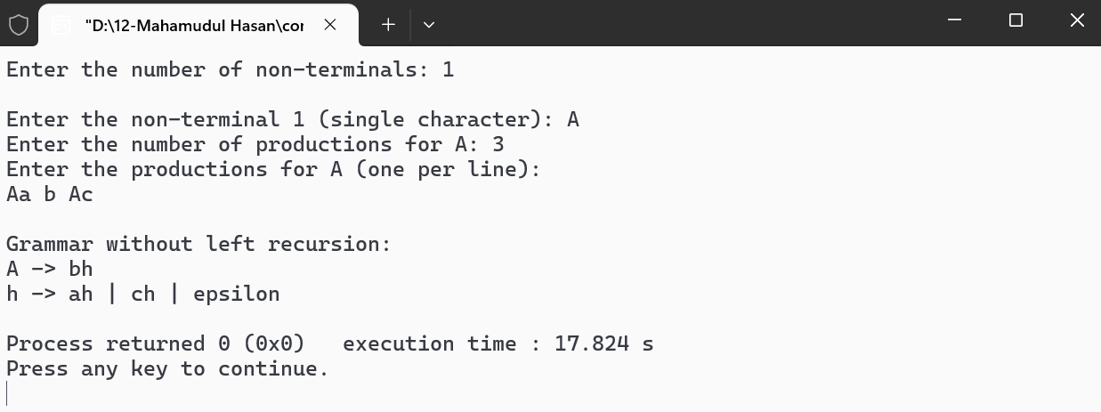

**Program 2: Performing Left Factoring**

#include <stdio.h>

#include <string.h>

#define MAX_RULES 10

#define MAX_LENGTH 100

#define MAX_NON_TERMINALS 10

typedef struct {

char non_terminal;

char productions[MAX_RULES][MAX_LENGTH];

int production_count;

} GrammarRule;

int longest_common_prefix(char *str1, char *str2) {

int i = 0;

while (str1[i] && str2[i] && str1[i] == str2[i]) {

i++;

}

return i;

}

void left_factoring(GrammarRule* rule) {

int prefix_length;

int common_prefix[MAX_RULES] = {0};

for (int i = 0; i < rule->production_count; i++) {

if (common_prefix[i]) continue;

for (int j = i + 1; j < rule->production_count; j++) {

prefix_length = longest_common_prefix(rule->productions[i], rule->productions[j]);

if (prefix_length > 0) {

char prefix[MAX_LENGTH];

strncpy(prefix, rule->productions[i], prefix_length);

prefix[prefix_length] = '\0';

printf("%c -> %sH\n", rule->non_terminal, prefix);

printf("H -> ");

int first = 1;

for (int k = i; k < rule->production_count; k++) {

if (longest_common_prefix(rule->productions[i], rule->productions[k]) == prefix_length) {

if (!first) printf(" | ");

printf("%s", rule->productions[k] + prefix_length);

common_prefix[k] = 1;

first = 0;

}

}

printf(" | epsilon\n");

break;

}

}

}

for (int i = 0; i < rule->production_count; i++) {

if (!common_prefix[i]) {

printf("%c -> %s\n", rule->non_terminal, rule->productions[i]);

}

}

}

int main() {

GrammarRule rules[MAX_NON_TERMINALS];

int num_non_terminals;

printf("Enter the number of non-terminals: ");

scanf("%d", &num_non_terminals);

for (int r = 0; r < num_non_terminals; r++) {

GrammarRule* rule = &rules[r];

rule->production_count = 0;

printf("\nEnter the non-terminal %d (single character): ", r + 1);

scanf(" %c", &rule->non_terminal);

int n;

printf("Enter the number of productions for %c: ", rule->non_terminal);

scanf("%d", &n);

printf("Enter the productions for %c (one per line):\n", rule->non_terminal);

for (int i = 0; i < n; i++) {

scanf("%s", rule->productions[rule->production_count++]);

}

}

printf("\nGrammar after left factoring:\n");

for (int r = 0; r < num_non_terminals; r++) {

left_factoring(&rules[r]);

}

return 0;

}

**Sample Input and Output**

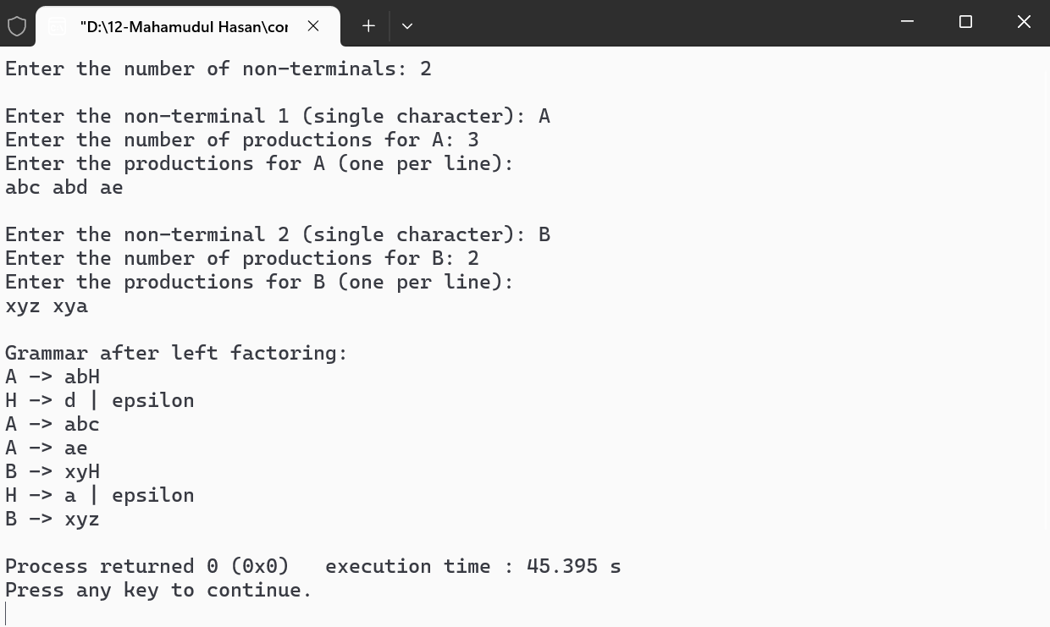**Conclusion**

The programs successfully eliminate left recursion and perform left factoring, enabling top-down parsing for grammars. The structured approach to modifying the grammar ensures compatibility with LL(1) parsers.